Welcome to Houston Christian University
Tip: The text above “Welcome to Houston Christian University” has been tagged as a Heading 1 using the Styles panel. This indicates that it is the most important text in the document (typically the title) and begins our document outline.
Tip: The text above “Explore HCU’s Campus” is the Husky Accessible Orange color (#C64027) and has sufficient contrast against the white background (#FFFFFF) which allows it to be more easily perceived by users.

HCU campus from above showing academic buildings, green lawns, parking lots, baseball field, and Belin Tower in view. 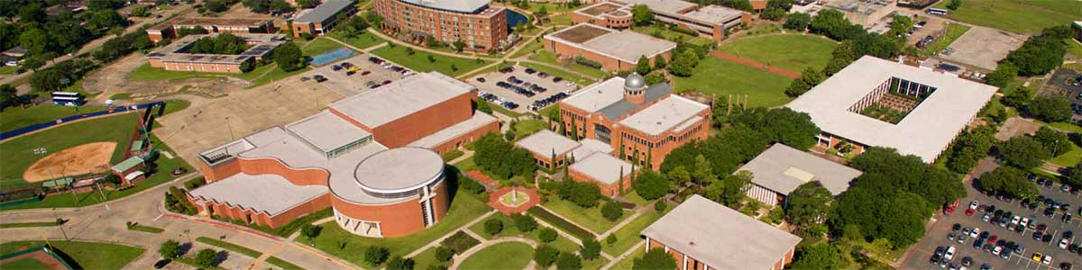
Tip: The image above has alt text added to the image properties to make it accessible to readers who cannot see the image. This was done by right clicking the image, selecting "Alt Text" and adding a brief descriptive sentence, in this case " HCU campus from above showing academic buildings, green lawns, parking lots, baseball field, and Belin Tower in view."

Getting Started
Tip: The text above “Getting Started” has been tagged as a Heading 2 using the Styles panel. This helps continue our document outline and creates a sub-section.

There are a few steps you should take in your first days on campus:
- Start by getting a student ID
- Register for required prerequisite classes
- Setup an appointment with your advisor
Tip: The text above has been formatted as a list. This increases readability and comprehension for all users. When possible, consider breaking content into lists.

Explore HCU’s Campus
Tip: The text above “Explore HCU’s Campus” has been tagged as a Heading 2 using the Styles panel. This helps continue our document outline and creates a sub-section.
Tip: The text above “Explore HCU’s Campus” is the Husky Blue color (#263B80) and has sufficient contrast against the white background (#FFFFFF) which allows it to be more easily perceived by users.

Museums
Tip: The text above “Museums” has been tagged as a Heading 3 using the Styles panel. This helps continue our document outline and creates another sub-section. Both “Museums” and “Campus Highlights” are sub-sections under “Explore HCU’s Campus.”
- Visit the HCU Museums
- Check out the HCU Fine Arts Museum
Tip: The links above are descriptive and allow a user to know what they’re getting when they click the link.

Campus Highlights
Tip: The text above “Dining Options” has been tagged as a Heading 3 using the Styles panel. This helps continue our document outline and creates another sub-section. Both “Museums” and “Campus Highlights” are sub-sections under “Explore HCU’s Campus.”
- Browse Restaurants at the Baugh Center
- Browse The Collegium where commuter students congregate
Tip: The links above have text that is descriptive and allows a user to know what they’re getting when they click the link

